Laravel WebSocket Installation & Configuration

BeyondCode ( https://beyondco.de/ ) package don’t work with laravel 8

1 Laravel Installation.

Prerequisites: It assumes you have PHP, MySQL, Composer, Node.js, Npm installed on your system.

Run the commands marked in bold dark-blue

composer create-project --prefer-dist laravel/laravel:^7.0 project_name

composer create-project --prefer-dist laravel/laravel project_name

composer create-project --prefer-dist laravel/laravel laravel-websocket

composer require beyondcode/laravel-websockets

php artisan vendor:publish --provider="BeyondCode\LaravelWebSockets\WebSocketsServiceProvider" --tag="migrations"

php artisan vendor:publish --provider="BeyondCode\LaravelWebSockets\WebSocketsServiceProvider" --tag="migrations"

composer require --with-all-dependencies beyondcode/laravel-websockets

cd project_name
php artisan –V
Laravel Framework 7.30.4

git init
git add .
git commit –m "Comment"

git remote add origin https://github.com/SergeyHub/repository-name.git
git push -u origin master

Edit env. file

mysql -u root -p
create database db_name;
drop database db_name;
exit

php artisan migrate

php artisan vendor:publish --provider="BeyondCode\LaravelWebSockets\WebSocketsServiceProvider" --tag="config"

Edit env. file

PUSHER_APP_ID=anyId
PUSHER_APP_KEY=anyKey
PUSHER_APP_SECRET=anySecret
PUSHER_APP_CLUSTER=mt1

php artisan serve
Laravel development server started: http://127.0.0.1:8000

http://127.0.0.1:8000/laravel-websockets

E:\laravel7-websocket\config\websockets.php

/*
* This path will be used to register the necessary routes for the package.
*/
'path' => 'laravel-websockets',
//'path' => 'admin/websocket',

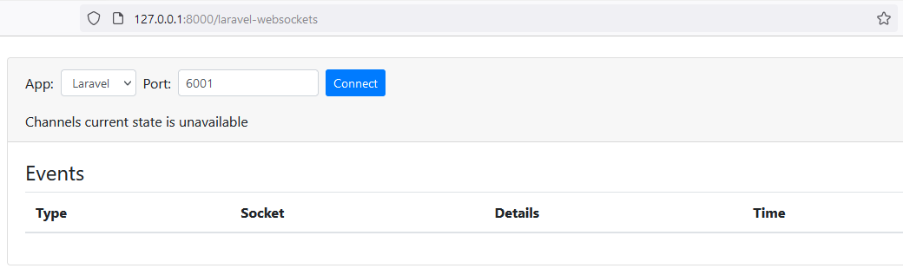

2. Basic Usage

Pusher Replacement

Requirements #

composer require pusher/pusher-php-server "~3.0"

Edit env. file

BROADCAST_DRIVER=pusher

Pusher Configuration #

When broadcasting events from your Laravel application to your WebSocket server, the default behavior is to send the event information to the official Pusher server. But since the Laravel WebSockets package comes with its own Pusher API implementation, we need to tell Laravel to send the events to our own server.

To do this, you should add the host and port configuration key to your config/broadcasting.php and add it to the pusher section. The default port of the Laravel WebSocket server is 6001.

Edit E:\laravel7-websocket\config\broadcasting.php

'pusher' => [
'driver' => 'pusher',
'key' => env('PUSHER_APP_KEY'),
'secret' => env('PUSHER_APP_SECRET'),
'app_id' => env('PUSHER_APP_ID'),
'options' => [
'cluster' => env('PUSHER_APP_CLUSTER'),
'useTLS' => true,
'host' => '127.0.0.1',
'port' => 6001,
'scheme' => 'http'
],
],

Usage with Laravel Echo #

npm install
npm install laravel-echo pusher-js

Edit E:\laravel7-websocket\resources\js\bootstrap.js

import Echo from 'laravel-echo';
window.Pusher = require('pusher-js');
window.Echo = new Echo({
broadcaster: 'pusher',
key: process.env.MIX_PUSHER_APP_KEY,
cluster: process.env.MIX_PUSHER_APP_CLUSTER,
wsHost: window.location.hostname,
wsPort: 6001,
disableStats: true,
});

npm run watch

Run in the second terminal

php artisan websocket:serve

Run in the third terminal

php artisan serve
http://127.0.0.1:8000/laravel-websockets
click connect

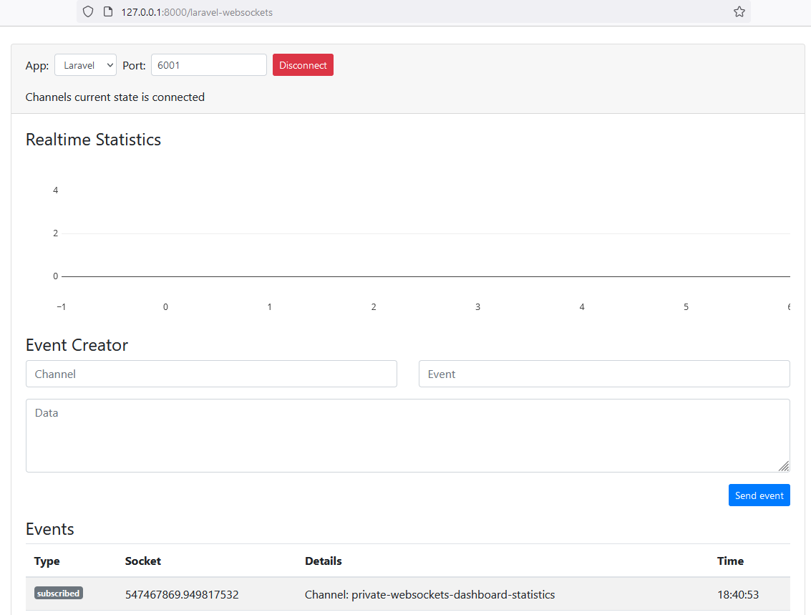

Run in the next terminal

php artisan make:event WebsocketDemoEvent

Edit E:\laravel7-websocket\app\Events\WebsocketDemoEvent.php

class WebsocketDemoEvent implements ShouldBroadcast
{
use Dispatchable, InteractsWithSockets, SerializesModels;
public $event_data;
/**
* Create a new event instance.
*
* @return void
*/
public function __construct($event_data)
{
$this -> event_data = $event_data;
}
/**
* Get the channels the event should broadcast on.
*
* @return \Illuminate\Broadcasting\Channel|array
*/
public function broadcastOn()
{
//return new PrivateChannel('channel-name');
return new Channel('DemoChannel');
}
}

Edit E:\laravel7-websocket\resources\js\bootstrap.js

window.Echo.channel('DemoChannel').listen('WebsocketDemoEvent' , (e) => {
console.log(e);
});

E:\laravel7-websocket\routes\web.php

use Illuminate\Support\Facades\Route;
use App\Events\WebsocketDemoEvent;
/*
|--------------------------------------------------------------------------
| Web Routes
|--------------------------------------------------------------------------
|
| Here is where you can register web routes for your application. These
| routes are loaded by the RouteServiceProvider within a group which
| contains the "web" middleware group. Now create something great!
|
*/
Route::get('/', function () {
broadcast(new WebsocketDemoEvent('event_data'));
return view('welcome');
});

Edit E:\laravel7-websocket\resources\views\welcome.blade.php

<meta name='csrf-token' content="{{ csrf_token() }}">
<body>
<div id="app" class="flex-center position-ref full-height">

<script src="js/app.js"></script>
</body>
</html>

\book>git init
\book>git add .
\book>git commit -m "Init"
\book>git remote add origin https://github.com/SergeyHub/Book.git
\book>git push -u origin master
Logon failed, use ctrl+c to cancel basic credential prompt.
Username for 'https://github.com': SergeyHub
Password for 'https://SergeyHub@github.com': my_password

composer require laravel/ui
composer require laravel/ui "^2.4" 7

php artisan ui bootstrap
php artisan ui bootstrap --auth

php artisan ui vue
php artisan ui vue --auth

npm i axios vform

npm install && npm run dev
npm run watch

php artisan migrate
php artisan serve

sudo chmod -R 775 storage/framework
sudo chmod -R 775 ./storage/logs
chmod -R 775 bootstrap/cache

sudo service apache2 restart

sudo chmod -R 777 /var/www/html Never use 777. With 777 permissions, you are giving anyone with a connection full access to the files or directories with those permissions. They may alter them in any way they choose, including maliciously. Many account hacking incidents stem from 777 permissions.

the requested url was not found on this server. Laravel

1. edit the apache2 conf to allow for symlinks etc
sudo nano /etc/apache2/apache2.conf

2. Add this to the file

<Directory /var/www/html/>
Options Indexes FollowSymLinks
AllowOverride all
Require all granted
</Directory>

3. Restart your apache2 server

sudo service apache2 restart

